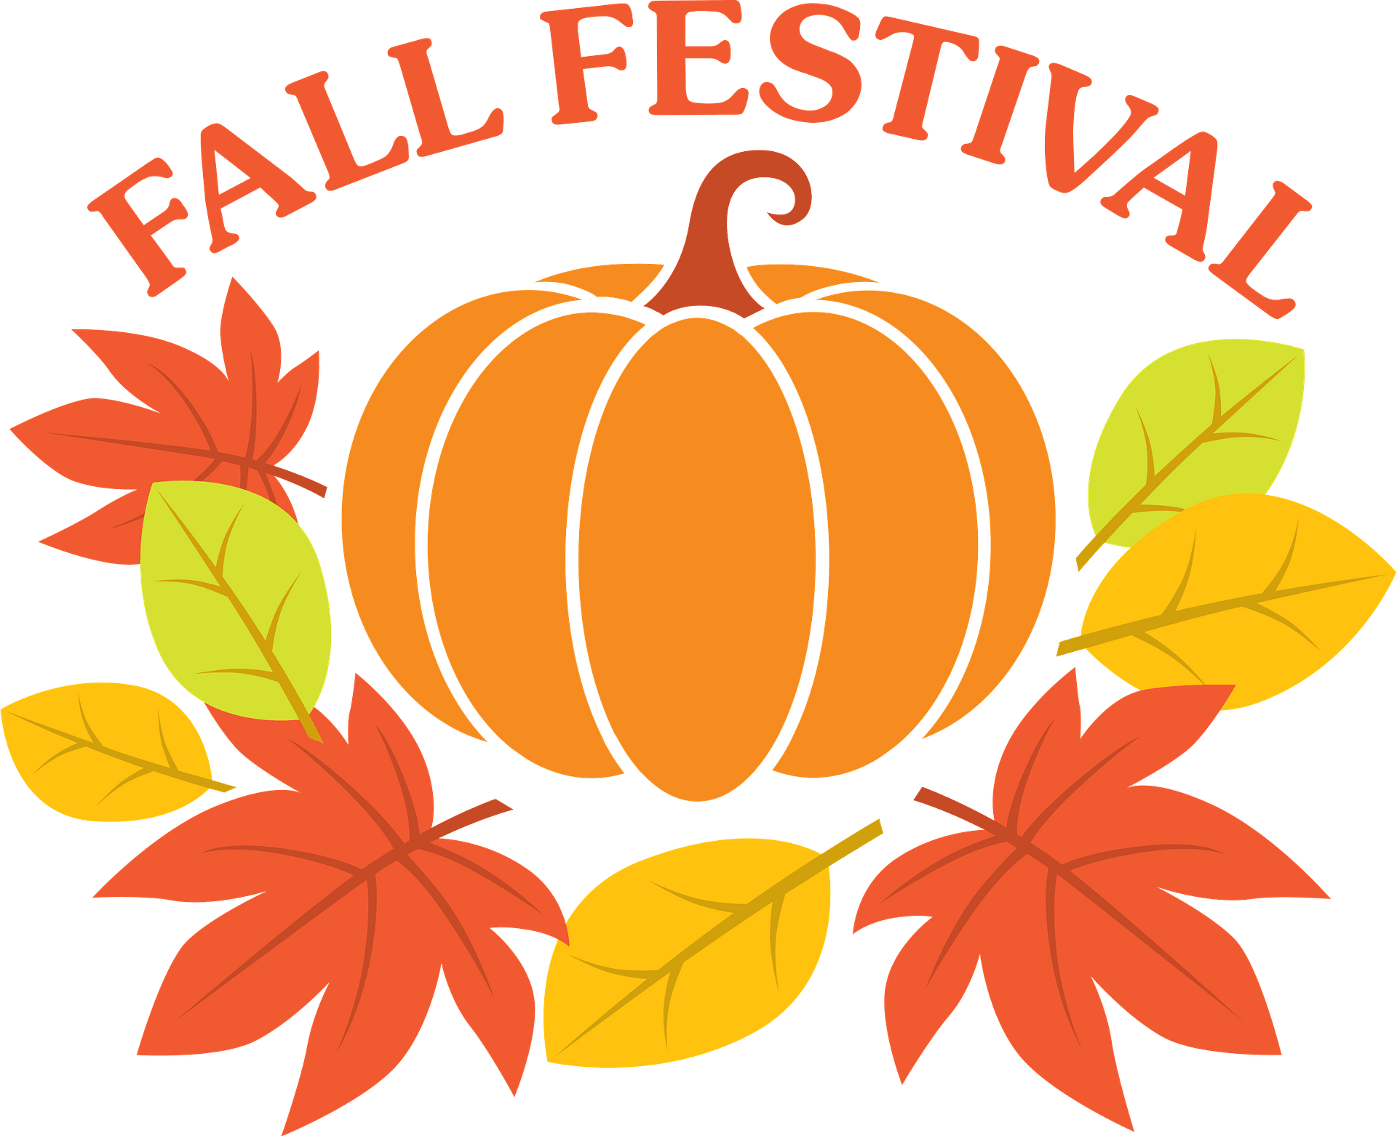 **October 4, 2025**

**5:00 p.m. – 8:00 p.m.**

**Everything is FREE!  
Bounce-houses, Food (BBQ & Hotdogs),   
BINGO, Hayrides (Handicap Accessible), Games for Kids, &  
Live Bluegrass Music  
  
  
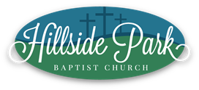  
  
7593 East Holly Grove Road  
Thomasville, NC 27360  
(336)472-6192  
Follow/Like Us On Facebook, Instagram & TikTok  
Subscribe to Our YouTube Channel  
www.hillsidepark.org**